**Appendices**

Appendix A

# Gantt Chart

Appendix B

# Work Plan

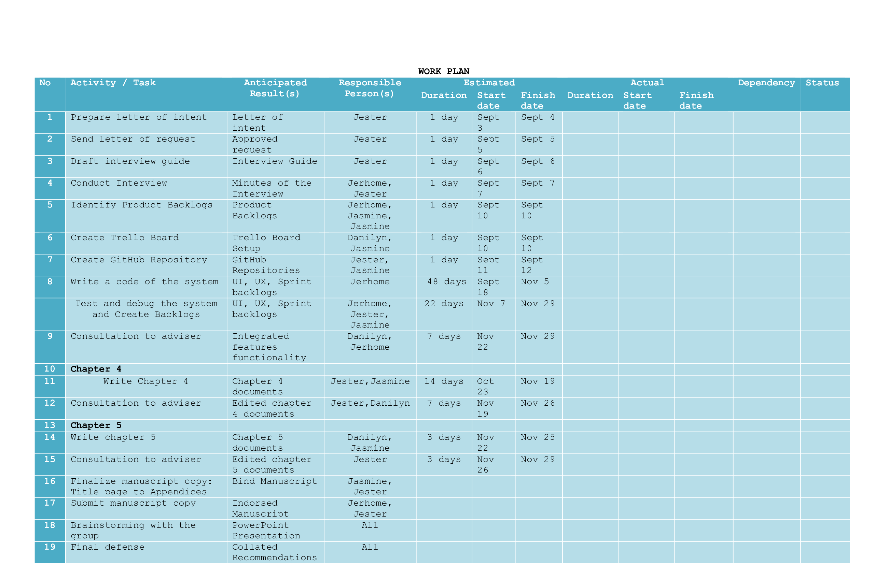

# Appendix C

# Letter to Conduct Studies

**REPUBLIC OF THE PHILIPPINES**

**PANGASINAN STATE UNIVERSITY**

Alaminos City Campus

**November 04 ,2022**

**MS. MARY C. DE GUZMAN**

*Municipal Tourism Officer*

*Bolinao, Pangasinan*

Madam:

Greetings Ms. De Guzman,

We are currently enrolled in the Bachelor of Science and Information Technology at Pangasinan State University – Alaminos City Campus and we are in the process of conducting a study on “TOURIST MONITORING SYSTEM FOR BOLINAO” in partial fulfillment of our requirements for Capstone Project 2.

We are humbly requesting your permission to conduct interviews, and observations, on the relevant processes of the Tourism Office that will help us to establish the scope and context of the project. We will treat every information shared and gathered with utmost confidentiality of our study will be highly appreciated response.

Thank you and looking forward to your positive response.

Sincerely,

**JERHOME T. REANTASO DANILYN V. BANOGON**

*Project Lead* *Member*

**JESTER EINSTEIN C. IBASAN JASMINE B. ZINAMPAN**

*Member Member*

Noted:

__________________ __

**CHRISTIAN PAUL O. CRUZ**

*Project Study Adviser*

__________________ __

**RUISSAN A. RAMOS, MIT**

*Department Chairperson*

*Information Technology*

Appendix D

# Interview Guide

The proponents in the study entitled, Tourist Management System for Bolinao had prepared the following sets of interview questions.

1. What is the peak season for tourist activities in Bolinao? How about the average number of tourists daily/weekly/monthly/annually?
2. What are the registered establishments and spots related to tourism in Bolinao? Is there any list of these available? Kindly share the offers of this establishments.
3. What is the primary workflow of Bolinao Tourism?
4. Who is responsible for processing tourist data?
5. How does information be handled in the office regarding tourist activities?
6. What is the information that are being processed? How does it help?
7. What does this collected tourist data mean to the office?
8. What is the existing process of Bolinao Tourism regarding monitoring tourists’ activities?
9. What is the current problem in the current process that is being ignored?
10. Do you feel like adding more interaction on the website like monitoring system? If yes, kindly enumerate.

Appendix E

# Use Case Diagram

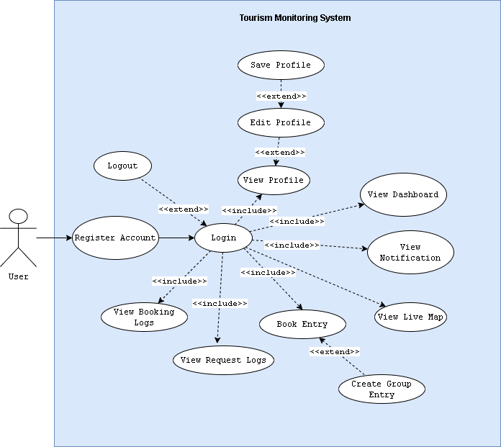

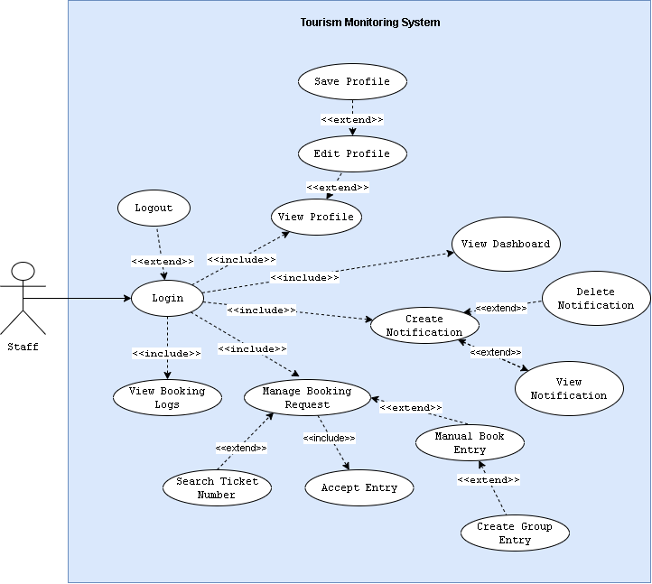

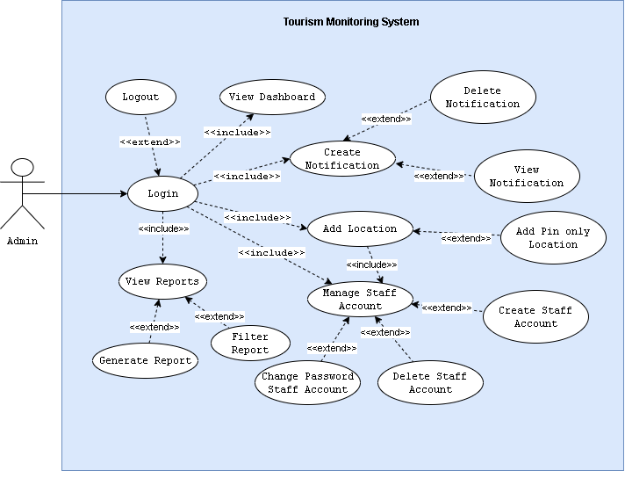

Appendix F

# Use Case Description

|  |  |  |
| --- | --- | --- |
| Use Case | Register | |
| Description | This is used to illustrate Signup in the system | |
| Actor | | System |
| Normal Flow | | |
| 2. Encode first name, last name, email, number, and password.  3. click Signup button.  5. Enter OTP Code from email inbox. | | 1. Display Sign up Page.  4. Send OTP via email.  6. Display Login page. |
| Except Flow (Encounter error in email or mismatch password) | | |
| 3. click Signup button.  5. Enter the valid email or password.  6. click Signup button  8. Enter OTP Code from email inbox. | | 4. Display error message for the email or password.  7. Send OTP via email.  8. Display Login Page. |

|  |  |  |
| --- | --- | --- |
| Use Case | Login | |
| Description | This is used to illustrate Login in the system | |
| Actor | | System |
| Normal Flow | | |
| 2. Encode email and password.  3. click Login button. | | 1. Display Login Page.  4. Display Dashboard. |
| Except Flow (Encounter error in password or phone number) | | |
| 3. click Login button.  5. Enter the correct password or email.  6. click Login button. | | 4. Display error message for the password or email.  7. Display Dashboard. |

|  |  |  |
| --- | --- | --- |
| Use Case | Profile | |
| Description | This is used to illustrate My Profile in the system | |
| Actor | | System |
| Normal Flow | | |
| 2. Edit first name, or last name, or gender, or phone number, or email, or address.  3. click Save Profile button. | | 1. Display Profile Page.  4. Display Updated Successfully. |
| Except Flow (Encounter error editing profile) | | |
| 2. Edit empty first name, or last name, or gender, or phone number, or email, or address.  5. Edit correct first name, or last name, or gender, or phone number, or email, or address.  6. click Save Profile button. | | 3. Display error message for empty first name, or last name, or gender, or phone number, or email, or address  7. Display Updated Successfully. |

|  |  |  |
| --- | --- | --- |
| Use Case | Notification | |
| Description | This is used to illustrate Notification in the system | |
| Actor | | System |
| Normal Flow | | |
| 1. Click notification bell icon.  3. Click new notification. | | 2. Display new notification.  4. Display notification modal. |
| Alternate Flow | | |
| 3. Click View All.  5. Click View on chosen notification. | | 4. Redirect to Notifications Page.  6. Display notification modal.  7. Display Updated Successfully |

|  |  |  |
| --- | --- | --- |
| Use Case | Live Map | |
| Description | This is used to illustrate Live Map in the system | |
| Actor | | System |
| Normal Flow | | |
| 2. Click Location Pin. | | 1. Display Live Map Page.  3. Display live count balloon. |

|  |  |  |  |  |
| --- | --- | --- | --- | --- |
| Use Case | Request Entry | | | |
| Description | This is used to illustrate Request Entry in the system | | | |
| Actor | | System | | |
| Normal Flow | | | | |
| 2. Click Next.  4. Choose desired location.  5. Click Request. | | 1. Display Booking – User Info Page.  3. Display Booking – User Info – Additional Information Page  6. Display generated ticket number. | | |
| Except Flow (Encounter error in requesting entry) | | | | |
| 2. Click Next.  5. Edit Profile.  6. Go to Request Entry Page.  8. Click Next.  10. Choose desired location.  11. Click Request. | | 3. Display error message for empty address.  7. Display Booking – User Info Page.  9. Display Booking – User Info – Additional Information Page  12. Display generated ticket number. | | |
| Alternate Flow | | | | |
| 4. Choose desired location.  5. Click Add More.  6. Encode required fields  8. Click Request. | | | | 7. Show new fields.  9. Display generated ticket number. |

|  |  |  |
| --- | --- | --- |
| Use Case | Accept Entry | |
| Description | This is used to illustrate Accept Entry in the system | |
| Actor | | System |
| Normal Flow | | |
| 2. Verify Ticket Number from User.  3. Confirm Entry. | | 1. Display Pending Request.  4. Update logs. |
| Alternate Flow | | |
| 2. Click Add Button.  4. Encode required fields. | | 1. Display Pending Request.  3. Redirect to Manual Entry Page.  5. Update logs. |

|  |  |  |  |  |
| --- | --- | --- | --- | --- |
| Use Case | Add Location | | | |
| Description | This is used to illustrate Add Location in the system | | | |
| Actor | | System | | |
| Normal Flow | | | | |
| 2. Click Next.  4. Choose desired location.  5. Click Request. | | 1. Display Booking – User Info Page.  3. Display Booking – User Info – Additional Information Page  6. Display generated ticket number. | | |
| Except Flow (Encounter error in requesting entry) | | | | |
| 2. Click Next.  5. Edit Profile.  6. Go to Request Entry Page.  8. Click Next.  10. Choose desired location.  11. Click Request. | | 3. Display error message for empty address.  7. Display Booking – User Info Page.  9. Display Booking – User Info – Additional Information Page  12. Display generated ticket number. | | |
| Alternate Flow | | | | |
| 4. Choose desired location.  5. Click Add More.  6. Encode required fields  8. Click Request. | | | | 7. Show new fields.  9. Display generated ticket number. |

|  |  |  |
| --- | --- | --- |
| Use Case | Create Staff Account | |
| Description | This is used to illustrate Create Staff Account in the system | |
| Actor | | System |
| Normal Flow | | |
| 1. Click Create Account.  3. Choose Location.  4. Encode password.  5. Click Create Account inside Modal. | | 2. Show Create Account Modal.  6. Show Successful message in modal. |
| Except Flow (Encounter error in Creating Staff Account) | | |
| 1. Click Create Account.  3. Click Create Account inside Modal.  5. Choose Location.  6. Encode password.  7. Click Create Account inside Modal. | | 2. Show Create Account Modal.  4. Display error (No fields)  8. Show Successful message in modal. |

|  |  |  |
| --- | --- | --- |
| Use Case | Generate Report | |
| Description | This is used to illustrate Generate Report in the system | |
| Actor | | System |
| Normal Flow | | |
| 1. Click Export as excel. | | 2. Download excel file. |
| Alternate Flow | | |
| 1. Choose Destination or All.  2. Choose Start Date and End Date.  3. Click Export as Excel. | | 4. Download excel file. |

Appendix G

# A picture containing text Description automatically generatedEntity Relationship Diagram

Appendix H

# Data Dictionary

|  |  |  |
| --- | --- | --- |
| **tr_db::admin_notifications** | | |
| Field Name | Type | Description |
| id (Primary) | bigint (20) | ID for query |
| sender | varchar (255) | Sender name |
| type | varchar (255) | Notification type |
| message | varchar (255) | Content of Message |
| status | varchar (255) | Status of Notification |
| sendto | varchar (255) | Where to send (user, admin, staff) |
| time | varchar (255) | Time of creation of notification |
| date | varchar (225) | Date of creation of notification |

|  |  |  |
| --- | --- | --- |
| **tr_db::approves** | | |
| Field Name | Type | Description |
| id (Primary) | bigint (20) | ID for query |
| booker_id | varchar (255) | Book ID |
| user_id | varchar (255) | User ID of User Accounts |
| staff_id | varchar (255) | User ID of Staff Accounts |
| first_name | varchar (255) | First name of the account |
| last_name | varchar (255) | Last name of the account |
| destination | varchar (255) | Destination of the account |
| gender | varchar (255) | Gender of the account |
| phone | varchar (255) | Phone number of the account |
| email | varchar (255) | Email address of the account |
| address | varchar (255) | Address of the account |
| book_number | varchar (255) | Generated Ticket Number |
| groups | varchar (255) | Number of Groups |

|  |  |  |
| --- | --- | --- |
| **tr_db::book_data** | | |
| Field Name | Type | Description |
| id (Primary) | bigint (20) | ID for query |
| booker_id | varchar (255) | Book ID |
| first_name | varchar (255) | User ID of User Accounts |
| last_name | varchar (255) | User ID of Staff Accounts |
| destination | varchar (255) | Destination of Account |
| gender | varchar (255) | Gender of the account |
| phone | varchar (255) | Phone number of the account |
| address | varchar (255) | Address of the account |
| book_number | varchar (255) | Generated Ticket Number |
| time_date | varchar (255) | Time & Date of Approval |
| day | varchar (255) | Day (Mon, Tues, etc.) |

|  |  |  |
| --- | --- | --- |
| **tr_db::book_requests** | | |
| Field Name | Type | Description |
| id (Primary) | bigint (20) | ID for query |
| user_id | varchar (255) | User ID of User Accounts |
| first_name | varchar (255) | First name of the account |
| last_name | varchar (255) | Last name of the account |
| destination | varchar (255) | Destination of the account |
| gender | varchar (255) | Gender of the account |
| phone | varchar (255) | Phone number of the account |
| email | varchar (255) | Email address of the account |
| address | varchar (255) | Address of the account |
| groups | varchar (255) | Number of Groups (0 or >1) |
| book_number | varchar (255) | Generated Ticket Number |
| status | tinytext | Status of Request |
| time_date | varchar (255) | Time & Date of Request |

|  |  |  |
| --- | --- | --- |
| **tr_db::daily reset** | | |
| Field Name | Type | Description |
| id (Primary) | bigint (20) | ID for query |
| user_id | varchar (255) | User ID of User Accounts |
| today | varchar (255) | Daily Reset Time Today |
| tomorrow | varchar (255) | Daily Reset Time Tomorrow |

|  |  |  |
| --- | --- | --- |
| **tr_db::group_approves** | | |
| Field Name | Type | Description |
| id (Primary) | bigint (20) | ID for query |
| booker_id | varchar (255) | Book ID |
| first_name | varchar (255) | First name of the account |
| last_name | varchar (255) | Last name of the account |
| destination | varchar (255) | Destination of the account |
| gender | varchar (255) | Gender of the account |
| phone | varchar (255) | Phone number of the account |
| address | varchar (255) | Address of the account |
| book_number | varchar (255) | Generated Ticket Number |
| time date | varchar (255) | Time & Date of Creation |
| ap_date | date | Date of Approval |

|  |  |  |
| --- | --- | --- |
| **tr_db::map_locations** | | |
| Field Name | Type | Description |
| id (Primary) | bigint (20) | ID for query |
| latitude | varchar (255) | Latitude of Map |
| longitude | varchar (255) | Longitude of Map |
| name | varchar (255) | Location Name |
| visit_count | varchar (255) | Visit Count of Location |
| total_visit | tinytext | Total Visit Increment |
| link | tinytext | Location Link |
| type | tinyint (4) | Pin or Establishment/Site |
| date | varchar (255) | Date of Creation |

|  |  |  |
| --- | --- | --- |
| **tr_db::staff_alerts** | | |
| Field Name | Type | Description |
| id (Primary) | Bigint (20) | ID for query |
| sender | varchar (255) | Sender name |
| type | varchar (255) | Notification type |
| message | varchar (255) | Content of Message |
| status | varchar (255) | Status of Notification |
| sendto | varchar (255) | Where to send(user, admin,staff) |
| time | varchar (255) | Time of creation of notification |
| date | varchar (225) | Date of creation of notification |

|  |  |  |
| --- | --- | --- |
| **tr_db::staff_notifications** | | |
| Field Name | Type | Description |
| id (Primary) | bigint (20) | ID for query |
| creator_id | varchar (255) | Creator ID |
| type | varchar (255) | Notification type |
| message | varchar (255) | Content of Message |
| status | varchar (255) | Status of Notification |
| time | varchar (255) | Time of creation of notification |
| date | varchar (225) | Date of creation of notification |

|  |  |  |
| --- | --- | --- |
| **tr_db::group_approves** | | |
| Field Name | Type | Description |
| id (Primary) | bigint (20) | ID for query |
| first_name | varchar (255) | Book ID |
| last_name | varchar (255) | First name of the account |
| phone | varchar (255) | Last name of the account |
| otp | varchar (255) | Generated OTP Code |
| email | varchar (255) | Email address of the account |
| gender | varchar (255) | Gender of the account |
| address | varchar (255) | Address of the account |
| img_name | varchar (255) | Profile image file name |
| img_size | varchar (255) | Image image file size |
| verification_code | varchar (255) | Generated verification code |
| is_verified | int (11) | Int-Boolean value for verification |
| password | varchar (255) | Hashed password |
| role | varchar (255) | User Level by number |
| book_number | varchar (255) | Generated Ticket Number |
| location | varchar (255) | Current Destination |
| remember_token | varchar (100) | Remember value |

|  |  |  |
| --- | --- | --- |
| **tr_db::user_notifications** | | |
| Field Name | Type | Description |
| id (Primary) | bigint (20) | ID for query |
| creator_id | varchar (255) | Creator ID |
| type | varchar (255) | Notification type |
| message | varchar (255) | Content of Message |
| status | varchar (255) | Status of Notification |
| time | varchar (255) | Time of creation of notification |
| date | varchar (225) | Date of creation of notification |

Appendix I

# Acceptability Questionnaire

ACCEPTABILITY TOURISM MONITORING SYSTEM FOR BOLINAO

(Adapted from ISO 9126-1 by McCall (1997))

Date: _____________________

Name of Respondent (optional): __________________________________

Sex: __ Male __ Female

Direction: Please evaluate/rate the following items to determine the acceptability of the Tourism Monitoring System for Bolinao by checking the corresponding box using the scale below:

4 – Acceptable

3 – Slightly Acceptable

2 – Slightly Unacceptable

1 – Unacceptable

|  |  |  |  |  |  |
| --- | --- | --- | --- | --- | --- |
| **Functionality** | | 4 | 3 | 2 | 1 |
| 1 | Suitability – The functions of the system are appropriate. |  |  |  |  |
| 2 | Accuracy – The system’s results are accurate. |  |  |  |  |
| 3 | Compliance – It adheres to existing standards and policies. |  |  |  |  |
| 4 | Security – It prevents unauthorized access. |  |  |  |  |
| **Reliability** | |  |  |  |  |
| 1 | Maturity – There is minimal frequency of software faults/failures. |  |  |  |  |
| 2 | Fault Tolerance – The system has capability of handling system errors. |  |  |  |  |
| 3 | Recoverability – System’s performance is re-establishing from failure. |  |  |  |  |
| **Usability** | |  |  |  |  |
| 1 | Understandability – Concepts are easily recognized. |  |  |  |  |
| 2 | Learnability – Effort in learning the system is reduced. |  |  |  |  |
| 3 | Operability – The system is easy to use or operate. |  |  |  |  |
| **Efficiency** | |  |  |  |  |
| 1 | Time Behavior – There is fast response time of the system. |  |  |  |  |
| 2 | Resource Behavior – Resources used for system performance are accessible. |  |  |  |  |
| **Maintainability** | |  |  |  |  |
| 1 | Analyzability – There is less effort in identifying system failure causes. |  |  |  |  |
| 2 | Changeability – Effort in modifying the system |  |  |  |  |
| 3 | Stability – Sensitivity to modification |  |  |  |  |
| **Portability** | |  |  |  |  |
| 1 | Adaptability – Specification changes are done easily. |  |  |  |  |
| 2 | Installability – There is effortless process of installing the system. |  |  |  |  |
| 3 | Conformance – System is compliant to portability standards. |  |  |  |  |

Comments:

_______________________________________________________________________________________________________________________________________________________________________________________________________________________________________________________________

This is the end of the survey questionnaire. Thank you very much for your time and generous cooperation.

_______________________

Respondent’s Signature

Appendix J

# Tabulation of Results

**Locale Respondents**

|  |  |  |  |
| --- | --- | --- | --- |
|  | | **Mean** | **Description** |
| **Functionality** | | 3.9 | Acceptable |
| 1 | Suitability – The functions of the system are appropriate. | 4 | Acceptable |
| 2 | Accuracy – The system’s results are accurate. | 3.88 | Acceptable |
| 3 | Compliance – It adheres to existing standards and policies. | 3.84 | Acceptable |
| 4 | Security – It prevents unauthorized access. | 3.88 | Acceptable |
| **Reliability** | | 3.73 | Acceptable |
| 1 | Maturity – There is minimal frequency of software faults/failures. | 3.56 | Acceptable |
| 2 | Fault Tolerance – The system has capability of handling system errors. | 3.88 | Acceptable |
| 3 | Recoverability – System’s performance is re-establishing from failure. | 3.76 | Acceptable |
| **Usability** | | 3.82 | Acceptable |
| 1 | Understandability – Concepts are easily recognized. | 3.88 | Acceptable |
| 2 | Learnability – Effort in learning the system is reduced. | 3.8 | Acceptable |
| 3 | Operability – The system is easy to use or operate. | 3.8 | Acceptable |
| **Efficiency** | | 3.9 | Acceptable |
| 1 | Time Behavior – There is fast response time of the system. | 3.92 | Acceptable |
| 2 | Resource Behavior – Resources used for system performance are accessible. | 3.88 | Acceptable |
| **Maintainability** | | 3.81 | Acceptable |
| 1 | Analyzability – There is less effort in identifying system failure causes. | 3.72 | Acceptable |
| 2 | Changeability – Effort in modifying the system | 3.92 | Acceptable |
| 3 | Stability – Sensitivity to modification | 3.8 | Acceptable |
| **Portability** | | 3.84 | Acceptable |
| 1 | Adaptability – Specification changes are done easily. | 3.72 | Acceptable |
| 2 | Installability – There is effortless process of installing the system. | 3.92 | Acceptable |
| 3 | Conformance – System is compliant to portability standards. | 3.88 | Acceptable |

**End-Users**

|  |  |  |  |
| --- | --- | --- | --- |
|  | | **Mean** | **Description** |
| **Functionality** | | 3.9 | Acceptable |
| 1 | Suitability – The functions of the system are appropriate. | 4 | Acceptable |
| 2 | Accuracy – The system’s results are accurate. | 3.88 | Acceptable |
| 3 | Compliance – It adheres to existing standards and policies. | 3.84 | Acceptable |
| 4 | Security – It prevents unauthorized access. | 3.88 | Acceptable |
| **Reliability** | | 3.73 | Acceptable |
| 1 | Maturity – There is minimal frequency of software faults/failures. | 3.56 | Acceptable |
| 2 | Fault Tolerance – The system has capability of handling system errors. | 3.88 | Acceptable |
| 3 | Recoverability – System’s performance is re-establishing from failure. | 3.76 | Acceptable |
| **Usability** | | 3.82 | Acceptable |
| 1 | Understandability – Concepts are easily recognized. | 3.88 | Acceptable |
| 2 | Learnability – Effort in learning the system is reduced. | 3.8 | Acceptable |
| 3 | Operability – The system is easy to use or operate. | 3.8 | Acceptable |
| **Efficiency** | | 3.9 | Acceptable |
| 1 | Time Behavior – There is fast response time of the system. | 3.92 | Acceptable |
| 2 | Resource Behavior – Resources used for system performance are accessible. | 3.88 | Acceptable |
| **Maintainability** | | 3.81 | Acceptable |
| 1 | Analyzability – There is less effort in identifying system failure causes. | 3.72 | Acceptable |
| 2 | Changeability – Effort in modifying the system | 3.92 | Acceptable |
| 3 | Stability – Sensitivity to modification | 3.8 | Acceptable |
| **Portability** | | 3.84 | Acceptable |
| 1 | Adaptability – Specification changes are done easily. | 3.72 | Acceptable |
| 2 | Installability – There is effortless process of installing the system. | 3.92 | Acceptable |
| 3 | Conformance – System is compliant to portability standards. | 3.88 | Acceptable |

**Tourism Officers**

|  |  |  |  |
| --- | --- | --- | --- |
| **Functionality** | | **Mean** | **Description** |
| 1 | Suitability – The functions of the system are appropriate. |  |  |
| 2 | Accuracy – The system’s results are accurate. |  |  |
| 3 | Compliance – It adheres to existing standards and policies. |  |  |
| 4 | Security – It prevents unauthorized access. |  |  |
| **Reliability** | |  |  |
| 1 | Maturity – There is minimal frequency of software faults/failures. |  |  |
| 2 | Fault Tolerance – The system has capability of handling system errors. |  |  |
| 3 | Recoverability – System’s performance is re-establishing from failure. |  |  |
| **Usability** | |  |  |
| 1 | Understandability – Concepts are easily recognized. |  |  |
| 2 | Learnability – Effort in learning the system is reduced. |  |  |
| 3 | Operability – The system is easy to use or operate. |  |  |
| **Efficiency** | |  |  |
| 1 | Time Behavior – There is fast response time of the system. |  |  |
| 2 | Resource Behavior – Resources used for system performance are accessible. |  |  |
| **Maintainability** | |  |  |
| 1 | Analyzability – There is less effort in identifying system failure causes. |  |  |
| 2 | Changeability – Effort in modifying the system |  |  |
| 3 | Stability – Sensitivity to modification |  |  |
| **Portability** | |  |  |
| 1 | Adaptability – Specification changes are done easily. |  |  |
| 2 | Installability – There is effortless process of installing the system. |  |  |
| 3 | Conformance – System is compliant to portability standards. |  |  |

**IT Staff – PSU ACC**

|  |  |  |  |
| --- | --- | --- | --- |
| **Functionality** | | **Mean** | **Description** |
| 1 | Suitability – The functions of the system are appropriate. |  |  |
| 2 | Accuracy – The system’s results are accurate. |  |  |
| 3 | Compliance – It adheres to existing standards and policies. |  |  |
| 4 | Security – It prevents unauthorized access. |  |  |
| **Reliability** | |  |  |
| 1 | Maturity – There is minimal frequency of software faults/failures. |  |  |
| 2 | Fault Tolerance – The system has capability of handling system errors. |  |  |
| 3 | Recoverability – System’s performance is re-establishing from failure. |  |  |
| **Usability** | |  |  |
| 1 | Understandability – Concepts are easily recognized. |  |  |
| 2 | Learnability – Effort in learning the system is reduced. |  |  |
| 3 | Operability – The system is easy to use or operate. |  |  |
| **Efficiency** | |  |  |
| 1 | Time Behavior – There is fast response time of the system. |  |  |
| 2 | Resource Behavior – Resources used for system performance are accessible. |  |  |
| **Maintainability** | |  |  |
| 1 | Analyzability – There is less effort in identifying system failure causes. |  |  |
| 2 | Changeability – Effort in modifying the system |  |  |
| 3 | Stability – Sensitivity to modification |  |  |
| **Portability** | |  |  |
| 1 | Adaptability – Specification changes are done easily. |  |  |
| 2 | Installability – There is effortless process of installing the system. |  |  |
| 3 | Conformance – System is compliant to portability standards. |  |  |

Appendix K

**List of Registered Establishments**

|  |  |  |  |
| --- | --- | --- | --- |
| Offers | Name of Establishment | [Gmail](mailto:ahhillside@gmail.com) | Location |
| Resort | A&H Hillside Resort | [ahhillside@gmail.com](mailto:ahhillside@gmail.com) | <https://goo.gl/maps/yMdjEmYSQaD2pvCK7> |
| Resort | Betty's Whitesand Beach | [bettyswhitesand10@gmail.com](mailto:bettyswhitesand10@gmail.com) | <https://goo.gl/maps/vrX9nNrMd6noMUiBA> |
| Resort | Birdland Beach Club Inc | [emruthpadilla@yahoo.com](mailto:emruthpadilla@yahoo.com) | <https://g.page/birdlandbeachclub?share> |
| Mabuhay Accomodation | Buccat Transienthouse | [williebuccat47@gmail.com](mailto:williebuccat47@gmail.com) | <https://goo.gl/maps/zv9HqhqTEf9G4E9PA> |
| Mabuhay Accomodation | Abode21 Guest House | [abode21house@gmail.com](mailto:abode21house@gmail.com) | <https://goo.gl/maps/dQi1zifBUGH39upM7> |
| Mabuhay Accomodation | Alona's Traditional Filipino Resthouse | [alonaovk7275@gmail.com](mailto:alonaovk7275@gmail.com) | <https://goo.gl/maps/y1zUNWaLWYsVQE3T8> |
| Resort | Ams Beach Resort | [alonaovk7275@gmail.com](mailto:alonaovk7275@gmail.com) | <https://goo.gl/maps/y1zUNWaLWYsVQE3T8> |
| Restaurant | B2l Sizzling House | [Lozanoemaemz@gmail.com](mailto:Lozanoemaemz@gmail.com) |  |
| Restaurant | Badak Restobar | [ritacatabay02@yahoo.com](mailto:ritacatabay02@yahoo.com) | <https://goo.gl/maps/GfhFexLFmUL3HEzn7> |
| Mabuhay Accomodation | Bolinao Beach House | [dahliaecal02@yahoo.com](mailto:dahliaecal02@yahoo.com) |  |
| Restaurant | Bolinao Seafood Grill Atbp. | [pangananbolinaoseafood@gmail.com](mailto:pangananbolinaoseafood@gmail.com) | <https://goo.gl/maps/ahsqWYWtVBse6n829> |
| Resort | Carino's Beach Resort | [perlitocarino@yahoo.com](mailto:perlitocarino@yahoo.com) | <https://goo.gl/maps/ScUUv4nKJFcmxhJ3A> |
| Restaurant | Casa Almarenzo Bed And Breakfast Resort | [reservations@casaalmarenzo.com](mailto:reservations@casaalmarenzo.com) | <https://goo.gl/maps/os3sekYZpsnNZ8u48> |
| Resort | Casa Carmencita Beach Resort | [reyvaldez0610@gmail.com](mailto:reyvaldez0610@gmail.com) | <https://goo.gl/maps/cYJCNiNVY3SfHirp7> |
| Resort | Casa Carolina Beach Resort | [charmilyn.abad.wat2016@gmail.com](mailto:charmilyn.abad.wat2016@gmail.com) | <https://goo.gl/maps/gDVG1CszzbAX3y5N8> |
| Mabuhay Accomodation | Casa Cristobal Inn | [imeldaschoenle01@yahoo.com](mailto:imeldaschoenle01@yahoo.com) | <https://goo.gl/maps/w59JraKNPXrRFKDx6> |
| Resort | Cindy's Bay View Resort | [cindysbayview@gmail.com](mailto:cindysbayview@gmail.com) |  |
| Tourism Recreation Center | Cindy's Cave Eco Park | [cindyscave@gmail.com](mailto:cindyscave@gmail.com) | <https://goo.gl/maps/4QyYNPJy96MYEAu38> |
| Resort | Cocos Beach Resort | [sidcocosbeach@gmail.com](mailto:sidcocosbeach@gmail.com) | <https://goo.gl/maps/FTyMSBMxxcAiQn3A8> |
| Resort | Cool Spot Beach Resort | [tiglaocharizza@gmail.com](mailto:tiglaocharizza@gmail.com) | <https://goo.gl/maps/JezWtRF6u4qdVP7j9> |
| Mabuhay Accomodation | Corpuz Transient House | [belindacorpuz01@yahoo.com](mailto:belindacorpuz01@yahoo.com) |  |
| Resort | Costa Del Fuego Beach Resort | [costadelfuegobeachresort@gmail.com](mailto:costadelfuegobeachresort@gmail.com) | <https://goo.gl/maps/KVL2Vm1VgmfEzmbH7> |
| Mabuhay Accomodation | D'haven Shores Inn | [havenshoresinn@gmail.com](mailto:havenshoresinn@gmail.com) | <https://goo.gl/maps/E5AVf4qcMGzA2Qci6> |
| Mabuhay Accomodation | De Vera's Transient Inn | [bettydevera@yahoo.com](mailto:bettydevera@yahoo.com) | <https://goo.gl/maps/4Fmdu3djpsGjDsyh9> |
| Mabuhay Accomodation | Del Luna Transient House | [bened8ct12@gmail.com](mailto:bened8ct12@gmail.com) | <https://goo.gl/maps/MDCedvFj5TYeqvy38> |
| Mabuhay Accomodation | Dela Cruz Transient House | [gemmapanes24@gmail.com](mailto:gemmapanes24@gmail.com) | <https://goo.gl/maps/ZGm9jtevTWZHPYYP9> |
| Resort | Diobes Beach Resort | [diobesorlanda@yahoo.com](mailto:diobesorlanda@yahoo.com) | <https://goo.gl/maps/ZdYGizBg5upLyDfW8> |
| Mabuhay Accomodation | Dor's Room Rental | [dorsroomrental@yahoo.com](mailto:dorsroomrental@yahoo.com) |  |
| Mabuhay Accomodation | Duclosan Convenient Mini Resto And Aiko Beach | [joanquebada01@yahoo.com](mailto:joanquebada01@yahoo.com) | <https://goo.gl/maps/ddegyg4jjUwysjUT9> |
| Resort | El Pescador Resort Hotel | [elpescadorofficial@gmail.com](mailto:elpescadorofficial@gmail.com) | <https://g.page/Elpescadorbolinao?share> |
| Mabuhay Accomodation | Elling's White Sand Transient Inn | [ildefonsocaslibjr@yahoo.com](mailto:ildefonsocaslibjr@yahoo.com) | <https://goo.gl/maps/V5Ht9TtanvXLL7P48> |
| Mabuhay Accomodation | Final Destination Villa Rental | [floridaweise@yahoo.com](mailto:floridaweise@yahoo.com) | <https://goo.gl/maps/ZMDF8cLxpaFLBJHU9> |
| Resort | Gerlita Beach Resort | [gerlitabeachresort@gmail.com](mailto:gerlitabeachresort@gmail.com) | <https://goo.gl/maps/YAiLzR7LZRjiPUoY6> |
| Mabuhay Accomodation | Glab Lavirginia Beach House | [gemmacramirez56@yahoo.com](mailto:gemmacramirez56@yahoo.com) | <https://goo.gl/maps/fYpZKgmkMZw3hDHA7> |
| Mabuhay Accomodation | Gran Canaria Vacation Place & Resto Bar | [grancanariapatar1@gmail.com](mailto:grancanariapatar1@gmail.com) | <https://goo.gl/maps/7JPx9WBdVSKCTJRD8> |
| Resort | Holy Land Beach Resort | [frudelinz@yahoo.com](mailto:frudelinz@yahoo.com) | <https://goo.gl/maps/BNJP5SGJyuDhEoAR7> |
| Resort | Honrada's Beach Resort | [nathanielangelito@yahoo.com](mailto:nathanielangelito@yahoo.com) | <https://goo.gl/maps/kecA6Hr65SZSFV6r9> |
| Resort | Hotel G Beach Resort And Restobar | [gbeachresort@gmail.com](mailto:gbeachresort@gmail.com) | <https://goo.gl/maps/TD1ZZXHjLvQAbFkF9> |
| Mabuhay Accomodation | Inson's Place Room Rental | [joanhonrada@yahoo.com](mailto:joanhonrada@yahoo.com) | <https://goo.gl/maps/DqxXL9BzuRLUbQFq9> |
| Restaurant | Jiajeimseu Korean Foodmart | [jamesghia12262015@gmail.com](mailto:jamesghia12262015@gmail.com) | <https://goo.gl/maps/t1e27Tf5pEZJ8GUg8> |
| Mabuhay Accomodation | Jjam's Transient Room Rental | [jjamstransient21@gmail.com](mailto:jjamstransient21@gmail.com) | <https://goo.gl/maps/TBpqMw5kFFqFhMPd9> |
| Restaurant | Kainan Sa Arko | [angelierosecanayon@gmail.com](mailto:angelierosecanayon@gmail.com) | <https://goo.gl/maps/Z2YfdCC5xt3tpvuq8> |
| Mabuhay Accomodation | Knb West Villa Inn | [knbwestvillainn21@gmail.com](mailto:knbwestvillainn21@gmail.com) | <https://goo.gl/maps/jXaxXQaQq1cnDcFR9> |
| Resort | Kokopeli Beach Resort | [liceralderenerose@gmail.com](mailto:liceralderenerose@gmail.com) | <https://goo.gl/maps/DY2os87sYk2kkwXM7> |
| Mabuhay Accomodation | Kubhotel Co. | [kubhotels@gmail.com](mailto:kubhotels@gmail.com) | <https://goo.gl/maps/VeJVB6vYdwdPQtFc6> |
| Mabuhay Accomodation | Kuya Ambot Staycation Beach House | [franciscojoel0463@gmail.com](mailto:franciscojoel0463@gmail.com) | <https://goo.gl/maps/e8CZBaitaMZZ2Zcm6> |
| Mabuhay Accomodation | Kuya Benjie's Transient Rooms | [benjaminsarte@yahoo.com](mailto:benjaminsarte@yahoo.com) | <https://goo.gl/maps/Dy7kcccU1LrrPj7n6> |
| Resort | Kyla's Resort | [venalynfallorina24@gmail.com](mailto:venalynfallorina24@gmail.com) | <https://goo.gl/maps/BPfTFCNf2hD9fbLSA> |
| Mabuhay Accomodation | La Casa De Quinn | [lacasadequinnpool@gmail.com](mailto:lacasadequinnpool@gmail.com) | <https://goo.gl/maps/YwftpxmspnErNQu56> |
| Resort | Liberty Beach Resort | [libertybeachresort2011@gmail.com](mailto:libertybeachresort2011@gmail.com) | <https://goo.gl/maps/VFa1Lb4FFPYD783a8> |
| Mabuhay Accomodation | Liway Beach Huts | [cartherineabalos68@gmail.com](mailto:cartherineabalos68@gmail.com) | <https://goo.gl/maps/xtbTjyqDN1vXBkxQA> |
| Mabuhay Accomodation | Los Ecijano's Inn | [losecijanosinn1@gmail.com](mailto:losecijanosinn1@gmail.com) | <https://goo.gl/maps/eToLeTYxp8KZw2xEA> |
| Mabuhay Accomodation | Magdha's Transient House | [magdhastransient04@gmail.com](mailto:magdhastransient04@gmail.com) | <https://goo.gl/maps/9HK5H8UKJ4nB64RZ8> |
| Mabuhay Accomodation | Makoko Sa Baybay | [miguel.natividad@rocketmail.com](mailto:miguel.natividad@rocketmail.com) | <https://goo.gl/maps/itDtCCziBVxPVkHH6> |
| Mabuhay Accomodation | Mario's Homestay | [marioshomestay12@gmail.com](mailto:marioshomestay12@gmail.com) |  |
| Mabuhay Accomodation | Mejia's Beach House | [edwincmejia@yahoo.com](mailto:edwincmejia@yahoo.com) | <https://goo.gl/maps/3AH8uqJEBfidknnQ7> |
| Mabuhay Accomodation | Mel-Gin Beach Hut Rental | [ricmorganizta@yahoo.com](mailto:ricmorganizta@yahoo.com) | <https://goo.gl/maps/1KPP3qrgKRiBizXKA> |
| Resort | Mia Al Mar Resort | [alsanchez.mci@gmail.com](mailto:alsanchez.mci@gmail.com) | <https://g.page/MiaAlMarBolinao?share> |
| Mabuhay Accomodation | Michael's Homestay | [geraldtamondong@gmail.com](mailto:geraldtamondong@gmail.com) | <https://goo.gl/maps/iRAQ4fDZ4pcNHm3B9> |
| Resort | Mjo White Sand Dream Resort | [mjowhitesanddreamresort@gmail.com](mailto:mjowhitesanddreamresort@gmail.com) | <https://goo.gl/maps/9NGiS6yv6Z3UFcWk8> |
| Mabuhay Accomodation | Myl Transient Room | [apostolsherrydee@gmail.com](mailto:apostolsherrydee@gmail.com) | <https://goo.gl/maps/sPZPmea4LXGRmn9dA> |
| Resort | Nelly's White Sand Beach Resort | [nellyramirez58@yahoo.com](mailto:nellyramirez58@yahoo.com) | <https://goo.gl/maps/88bpJPg7zgBxGtzp8> |
| Mabuhay Accomodation | Noe's Room Rental | [noesarkbolinao@gmail.com](mailto:noesarkbolinao@gmail.com) |  |
| Mabuhay Accomodation | Patar Summer Inn | [patarsummerinn@gmail.com](mailto:patarsummerinn@gmail.com) | <https://goo.gl/maps/BqBfWQWbVc1BpsDx9> |
| Resort | Paz Beach Resort | [pazbeachresort@gmail.com](mailto:pazbeachresort@gmail.com) |  |
| Resort | Pearlcasa Resort | [pearlcasabr@gmail.com](mailto:pearlcasabr@gmail.com) | <https://goo.gl/maps/RMvLeVmwbBqdHbsf7> |
| Resort | Precious Zion Beach Resort | [fujiapplelua@gmail.com](mailto:fujiapplelua@gmail.com) | <https://goo.gl/maps/NXPndeKeFZCwNpa99> |
| Mabuhay Accomodation | Puerto Del Sol Beach Resort And Hotel Club | [sales1.puertodelsol@gmail.com](mailto:sales1.puertodelsol@gmail.com) | <https://goo.gl/maps/gbcJqDMuo729QLo67> |
| Mabuhay Accomodation | Punta Riviera Del Mar Inc. | [puntarivieraresort@yahoo.com](mailto:puntarivieraresort@yahoo.com) | <https://goo.gl/maps/AFTChvJDYLSfVrEi6> |
| Resort | R-M Beach Resort | [renecapena05@yahoo.com](mailto:renecapena05@yahoo.com) | <https://goo.gl/maps/G5YGFUBeuYBnfXzZA> |
| Mabuhay Accomodation | Racniel Beach House Rental | [racnielbeachhouserental@gmail.com](mailto:racnielbeachhouserental@gmail.com) | <https://goo.gl/maps/myXmcizZL85MhmCG8> |
| Resort | River Village Resort | [rivervillageresort2022@gmail.com](mailto:rivervillageresort2022@gmail.com) | <https://goo.gl/maps/RYF5q6Cmwd3D4Wob6> |
| Mabuhay Accomodation | Rock Formation View Beach | [rosalyncatabay@yahoo.com](mailto:rosalyncatabay@yahoo.com) | <https://goo.gl/maps/yAQbk7F7MWrb85ht9> |
| Resort | Scl Garden Resort | [sclgardenresort@yahoo.com](mailto:sclgardenresort@yahoo.com) | <https://goo.gl/maps/woZgh1qR273tEn6o7> |
| Mabuhay Accomodation | Sea-Esta Beach House | [randyohonrada@yahoo.com](mailto:randyohonrada@yahoo.com) | <https://goo.gl/maps/oSjsBB9u4bAKPewLA> |
| Mabuhay Accomodation | Serenity Inn | [aliciaebidag01@yahoo.com](mailto:aliciaebidag01@yahoo.com) | <https://goo.gl/maps/ESECqjwwUQw5UJUC8> |
| Resort | Shaded Sand Beach Resort | [jiebenj@yahoo.com](mailto:jiebenj@yahoo.com) | <https://goo.gl/maps/FdFzyZ4yEVTQsh7V9> |
| Resort | Stella's Place Beach Resort | [stellasplace10@gmail.com](mailto:stellasplace10@gmail.com) | <https://goo.gl/maps/tHCzYZVUWevx1RYbA> |
| Mabuhay Accomodation | Sundowners Vacation Villas | [laurie.labuson@sundowners.biz](mailto:laurie.labuson@sundowners.biz) | <https://goo.gl/maps/S2ZKDkdSHJmHo8HZ7> |
| Resort | Taberna De Orlanda Resort | [pauloorlanda@yahoo.com](mailto:pauloorlanda@yahoo.com) | <https://goo.gl/maps/mv8akELvHsWn4QUc8> |
| Resort | Treasures Of Bolinao Beach Resort | [info@treasuresofbolinao.com](mailto:info@treasuresofbolinao.com) | <https://g.page/treasuresofbolinao?share> |
| Restaurant | Tummy Teasers Foodhouse And Bakeshop | [jayrontorres@yahoo.com](mailto:jayrontorres@yahoo.com) | <https://goo.gl/maps/vTgwmcgZhLMphnR1A> |
| Mabuhay Accomodation | Veue Beach Cabins | [info@veue.ph](mailto:info@veue.ph) | <https://goo.gl/maps/JdveMjyEbG5qQbjF6> |
| Resort | Villa Estrella Beach Resort | [casaestrellapatar@gmail.com](mailto:casaestrellapatar@gmail.com) |  |
| Mabuhay Accomodation | Villa Laguisma Transient House | [villalaguismatransient@gmail.com](mailto:villalaguismatransient@gmail.com) |  |
| Resort | Villa Soledad Beach Resort, Corp. | [villasoledadbeachresort@yahoo.com](mailto:villasoledadbeachresort@yahoo.com) | <https://goo.gl/maps/cXuhHY2zUYcVSCuQ9> |
| Mabuhay Accomodation | Wrc Beach House | [wrcbeachresort@gmail.com](mailto:wrcbeachresort@gmail.com) |  |
| Restaurant | Yobistro By The Sea, Inc. Doing Business Under Ciao | [ciao.sundowners@gmail.com](mailto:ciao.sundowners@gmail.com) |  |

**Total Number of Registered Establishments**

|  |  |
| --- | --- |
| Offers | Number |
| Mabuhay Accommodation | 44 |
| Resort | 35 |
| Restaurant | 8 |
| Tourism Recreation Center | 1 |
| Total Number: | **88** |

Appendix L

# Certification of Grammar Check